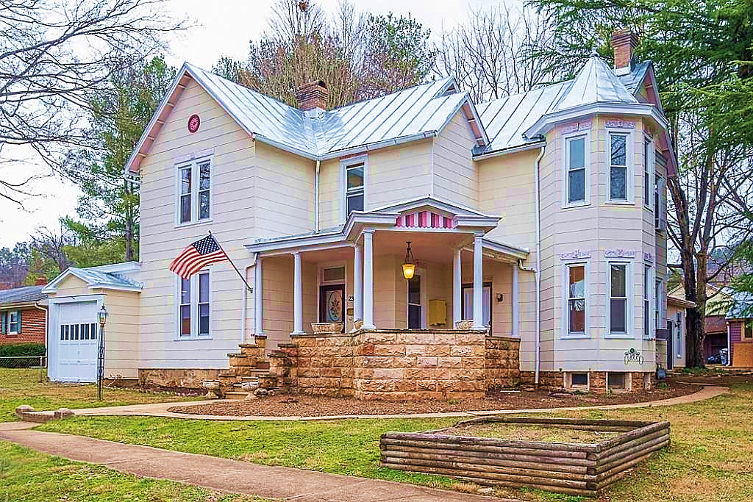
Rehabilitated Residential Real Estate Tax Exemption


What is the Rehabilitated Residential Real Estate Tax Exemption?
To encourage major renovation of houses and apartments, the City will freeze the assessed value of certain rehabilitated residential structures for up to 10 years. This means that for the first five or ten years after renovation, property owners pay tax on the pre-renovation value of the building. The duration of the exemption is based on the age of the building.
Eligibility
- Building is residential (at least 80% if a mixed-use building)
- Building is at least 50 years old (5-year exemption) or 75 years old (10 year exemption)
- Rehabilitation increases assessed value of building by at least 40%
Incentive and Application
The amount of the increased in the assessed value of the structure after rehabilitation, over its assessed value at the date of application, is exempted from real estate tax.
Application must be made to the Department of Community & Economic Development. Conditional approval may be granted based on plans submitted prior to rehabilitation, but the exemption will not be granted until completion of the work. There is an application fee of $20.00.

